Fork Instructions

**Project :** <https://github.com/Subhajit77/Java-React-Demo/>

**Log in to GitHub**: Login into your GitHub account.

**Fork the Repository**:

* Go to the GitHub repository URL : <https://github.com/Subhajit77/Java-React-Demo/>
* In the upper-right corner of the page, click on the "Fork" button.
* Select your GitHub account or the organization where you want to fork the repository.

**Clone the Repository**:

* On your forked repository, click the green "Code" button.
* Copy the repository URL (HTTPS, SSH, or GitHub CLI).

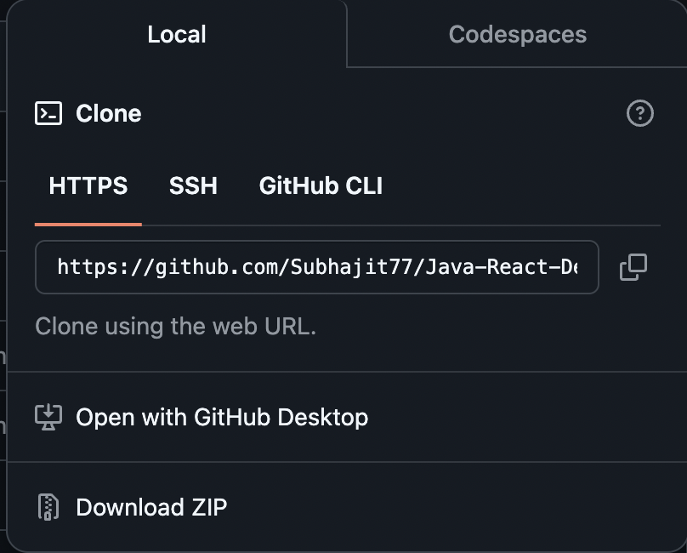

**System / VS Code Dependencies** :

* Install Java
* Install VS Code
* Install VS Extensions for Terraform, Java, Maven, Azure CLI